LAB EXERCISE- Using Maps to Assess Volcanic Hazards
Overview
Kilauea , on the Big Island of Hawaii, is one of the most active volcanoes in the world. Because Kilauea erupts so frequently, it poses serious natural hazards to residents and the surrounding environment. The scientists at the Hawaiian Volcano Observatory (HVO) continually monitor Kilauea’s eruptive and gas activity in order to make predictions and assess the dangers to people and properties in the region.
The eruptive activity from Kilauea originates from the summit caldera or along the east or southwest rift zones.
You are a HVO scientist who will be assessing the natural hazards associated with Kilauea’s activity including the dangers to people and properties in the region. There are three parts to this lab assignment: a pre-lab, lab, and news report. The pre-lab should be completed before attending the lab. In the pre-lab you will be asked to look at the style of volcanism associated with Pu’u O’o cone, a cinder-and-spatter cone located in the east rift zone:
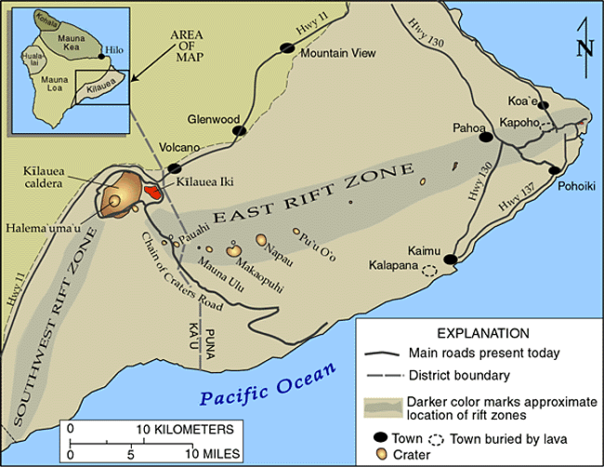
Map from HVO, at http://hvo.wr.usgs.gov/kilauea/Kilauea_map.html
This a general map of atmospheric circulation patterns. You will be using this later in the lab to predict wind direction:
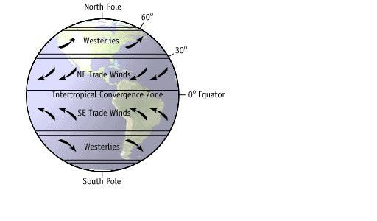
Map from: http://www.nps.gov/archive/grsa/resources/curriculum/mid/dunes/photo_files/global_wind.htm
In the lab you will be provided with 3 topographic and 1 geologic map to assess the natural hazards associated with Kilauea’s activity including the dangers to people and properties in the region. You will be responsible for creating your own set of maps and materials from the pre-lab and lab exercises.
The third part of the assignment involves writing an accompanying news report to communicate the results of your work to the public. While you are encouraged to discuss all parts of the assignment with your peers, you must hand in your own work.
Part 1.
Your topographic map will need to be updated to reflect eruptive activity from 1983 to the present, as well as the new structures and settlements that have since developed in the region.

1. The 1977 lava flow moved in which direction?

2. What is the gradient of the 1977 lava flow?

Using your geology map, add the lava flows from 1983-present onto your topographic map. Use a different color for each lava flow and make a legend indicating which color represents which flow. Now add three farms to your topographic map. Each farm should be drawn as a square with each side measuring 3,000 feet, centered on the three following points:
 | Latitude | Longitude
Macadamia Nut Farm | 19°20’N | 155°05’
Coffee Farm | 19°20’N | 155°03’
Tropical Flowers Farm | 19°20’N | 155°07’

3. How many other flows are there in the region (from 1983-present)? In which direction did these flows move?

4. Explain why it might be important to HVO scientists to understand and monitor the direction of lava flows in the surrounding area.

Part II.
There is a new lava flow that you have named that originated from a vent located at 19°21’00’’N and 155°05’00’’ W. Mark this point on your topographic map with a star. The new lava flow is approximately 4 miles long, 1 mile wide and 20 ft thick. The gas plume extends 5 miles from the vent.
5. What is the elevation at the point where the new lava flow takes place?
6. Draw the new lava flow on your topographic map in a new color. Add this to your legend. Predict the direction of movement of the new lava flow:
a) Is the Macadamia Nut Farm going to be affected by gas/lava?

b) Is the Coffee Farm going to be affected by gas/lava?

c) Is the Tropical Flower Farm going to be affected by gas/lava?

7. Is the new lava flow entering the sea? Why might this be potentially hazardous?

8. Describe all areas affected by the volcano, including all hazards discussed in the lab introduction.

9. If the viscosity were increased, how would that affect the shape of the lava flow?

10. How would the impact of the eruption differ if the volcano were more felsic?

11. There are universal worldwide scales for tornadoes, hurricanes, earthquakes, etc. Evaluate how and why you might develop a worldwide scale for volcanic hazards, including any challenges you may encounter.

12. What data would be needed to properly assess risk?

Part III. News Project
11. You are a news reporter covering the newest phase of the eruption. Your news report should be addressed to the public, using general terminology and answering the following questions:
- Based on what you learned in the lab, how is the topography being changed in the region?
- Describe where the eruptive activity is occurring. What hazards are of major concern in which regions? (Hint: Use the map below to describe the hazard zones and areas of activity):
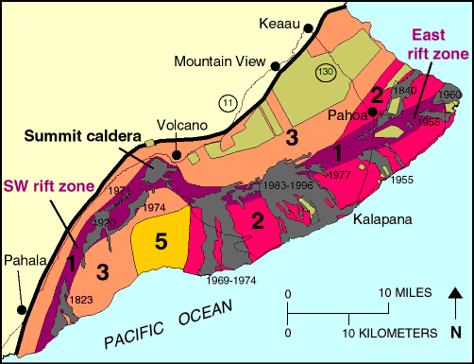
Map and table from HVO, at http://pubs.usgs.gov/gip/hazards/maps.html
HAZARD ZONES FOR LAVA FLOWS
Zone | Percentage of area covered by lava since 1800 | Percentage of area covered by lava in last 750 years | Explanation
1 | greater than 25 | greater than 65 | Includes the summits and rift zones of Kilauea and Mauna Loa where vents have been repeatedly active in historic time.
2 | 15-25 | 25-75 | Areas adjacent to and downslope of active rift zones.
3 | 1-5 | 15-75 | Areas gradationally less hazardous than Zone 2 because of greater distance from recently active vents and/or because the topography makes it less likely that flows will cover these areas.
4 | about 5 | less than 15 | Includes all of Hualalai, where the frequency of eruptions is lower than on Kilauea and Mauna Loa. Flows typically cover large areas.
5 | none | about 50 | Areas currently protected from lava flows by the topography of the volcano.
6 | none | very little | Same as Zone 5.
7 | none | None | 20 percent of this area covered by lava in the last 10,000 yrs.
8 | none | None | Only a few percent of this area covered in the past 10,000 yrs.
9 | none | None | No eruption in this area for the past 60,000 yrs.

- What, if any, structures or settlements have been affected in the region? How are residents responding to any damages inflicted by the eruption within the vicinity?

